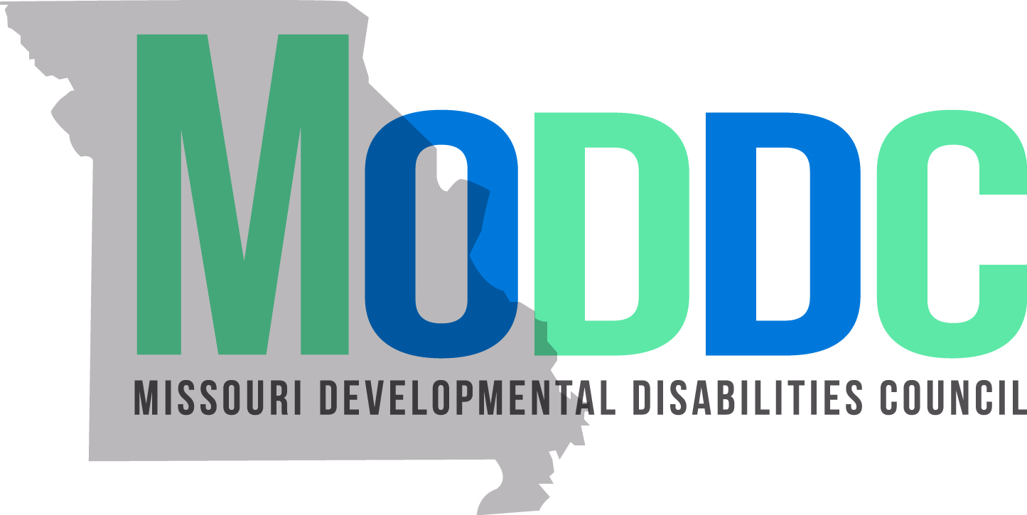

Sexuality Education NoFA Question and Answer (Q&A)
The following documents were requested in the Q&A and are posted below:
- MODDC 5 Year Plan
- Sample Budget Sheet for Application
Questions from Q&A on May 4, 2022
- Can you provide more clarification on the scope of work where it indicates train the trainer model?
  - Participants will be brought up through the program to be trained as trainers. The NoFA indicates that of the people that participate over the three year span of this project (100 minimum), 20% of those people are trained as trainers. This is over the entire 3 year period. 60 % of the 20% trained would be self-advocates.
- Is this being awarded to only one organization?
  - Yes, this will be awarded to one applicant.
- Would the grantee need to develop the way to train the trainers or are applicants expected to find a companion, nationally-recognized way, to train the trainers to go with the curriculum?
  - For whatever curriculum is selected, a train the trainer component would need to be identified. Whether this is built into the already selected curriculum, or developed in addition is up to the grantee and dependent on the curriculum selected.
- Is the Council looking for this to be statewide, or is it just as long as urban and rural is covered?
  - It is stated on Page 4 of the NoFA that the project “engages both urban and rural populations…”. As long as that stipulation is satisfied, there are no additional requirements.
- Can you clarify the requirements on approval of curriculum? There are areas of the NoFA that state self-advocates need to approve and then another area saying that the Council approves.
  - It is stated on Page 3 of the NoFA that the grantee will “Survey self-advocates and advocates to help guide curriculum selection and determine unmet needs in this community”. It is expected that the grantee would, before selecting the curriculum they would like to use, include feedback from self-advocates and advocates to help them come to this decision.
  - The MODDC approval is stated on Page 2 under “Project Description and Scope of Work” that, “The final curriculum would be approved by MODDC staff.” This is to ensure compliance with the scope of the grant and ensure quality control.
- How do we account for providing accommodations for accessibility and language accommodations? There is a certain element of having to guess at what you will need since you don’t know what the participant pool will look like. Do you put a certain amount in and spend what you have? Or, are there more resources around accessibility if you have more accommodations than what you budgeted? For example, put $10,000 into accommodations budget, but it ends up being $15,000. Are there more funds to tap into?
  - The Council could consider adding funding to allow for increased accessibility and language accommodations if there was a need. However, budgets should just be an estimation of costs based on the information available. During the three year period of the project, specific line items in proposed budgets can be adjusted as long as the scope and intent of the grant remains the same.
- Does the whole curriculum have to be in Spanish or just the tools that are used?
  - The grantee should offer Spanish speakers the accommodation of translated materials for whatever facet of the program they are participating in. All external recruitment materials should be promoted in Spanish. If those who enroll in the program select Spanish as their preferred language, it is expected that materials they would need to complete their program is made available in Spanish.
- Are you hoping that the 20% of train the trainers get their curriculum and training materials in Spanish? Or is it about the participants in the class having access to the material?
  - See answer to question 7.
- Regarding recruitment of participants ages 15 and older, is there a target audience? Do we want to make sure we hit all of the age ranges?
  - On page 4 of the NoFA document, it states that communication and recruitment, “Engages youth ages 15 (beginning of High School) - older adults, aged 65+. This can be interpreted as the pool of people from which to pull participants. There are no further specifications or requirements around age demographics.
- Since the grantee would not be producing anything with these funds, but providing trainings, what becomes the intellectual property of the Council?
  - We are not paying for a curriculum to be developed, so it is not the product of this grant. The curriculum would not be the intellectual property of the Council. However, any images or promotional materials for marketing the events or work of this grantee would be the property of the Council.
- If we can’t find a train the trainer process that is already accessible, would that be up to the grantee to develop an accessible format for the train the trainer process?
  - Yes.
- For funding and funding match, we will likely distributing the program across the state. How does that work? How does that effect our match if both poverty and non-poverty counties are being served?
  - In light of recent updates from our federal funding source as it pertains to this topic, we are actively evaluating how to answer this question. At the time of publication, the final answer was not available to us. This questions will be updated with the answer as soon as it is available. If you want to be on an email list for this particular update, please email lhaun@moddcouncil.org and indicate that you would like to receive this update.
- The NoFA mentioned scholarships? Does this meant that there is a cost to participate in the training?
  - On page 5 of the NoFA, under “Project Description and Scope of Work”, it is stated that grantees will, “Develop and implement a scholarship/reimbursement process to cover expenses for training participants who may not be able to afford to participate otherwise.” While there will no fee to take the course, this would be to remove any barriers to transportation or lodging that may be necessary if there are in person components of this training.
- Is there a feeling on providing scholarships for everyone to ensure there are no barriers across the board?
  - This is allowable within the scope of this grant. This would need to be accounted for and reflected in a proposed budget.
- What type of organization is eligible for this grant? Non-Profits? For Profits?
  - On Page 8 of the NoFA under “Requirements: Qualifications and Organizational Experience” it states that “Any organization that receives a MODDC grant must be able to disburse funds for project activities and expenses, complete forms correctly and on time, and be legally able to receive grant funds to reimburse the organization for expenses.” This is the only requirement of the organization structure to receive MODDC funds.
- Is there a person at the DD Council that would work on this project specifically? Is there a particular person.
  - Yes, Leigh Anne Haun will serve as the project manager for this grant.
- Does that mean you could help with recruitment plans and contacts for potential participants?
  - Yes, we want this to be a partnership and will engage with the grantee to connect them with cultural brokers and groups with whom we are in contact. Though grantees will be expected to build on contacts made to develop a robust pool of participants and to meet numbers and metrics in the scope of work.

- I don’t see a budget template - do you have one?
  - Yes, a budget template can be found here.
- What percentage is allowable for indirect costs?
  - MODDC allows for a maximum of 11.2% indirect cost for a project applied to MODDC funding, not the total project cost. Any questions regarding how this policy would interact with a current organization or university policy on accepting grant funds should be referred to internal resources and grant managers.
  - For more information on indirect costs, refer to the iTACC resource on this webpage, page 11.

